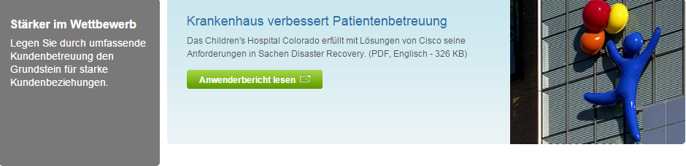

5

4

3

2

1

6

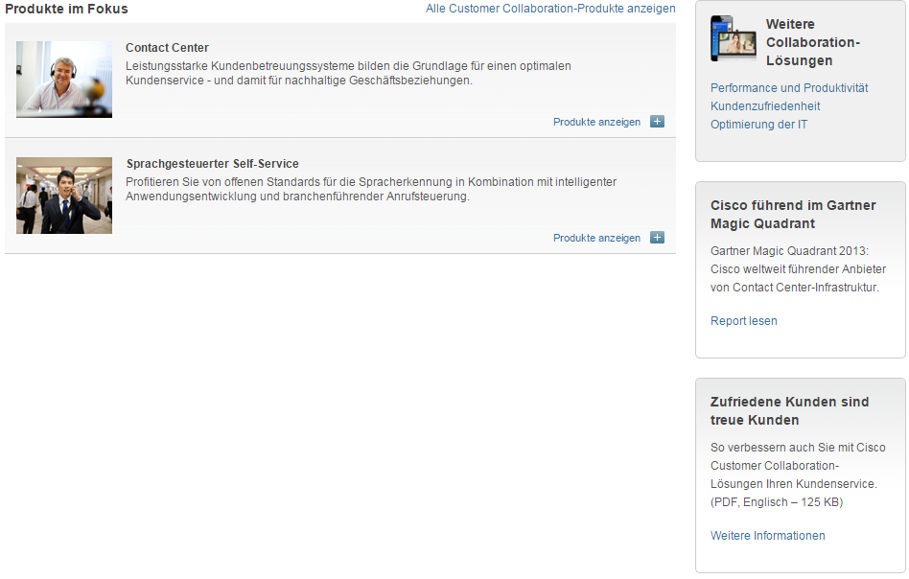

10

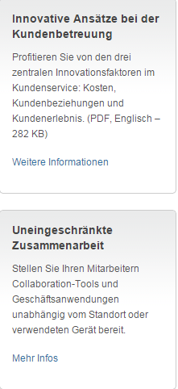

9

8

7

|  |  |  |  |
| --- | --- | --- | --- |
| 1 | /content/<locale>/products/customer-collaboration/index/jcr:content/content_parsys/overview/layout-overview/gd12v1/gd12v1-left/primary_cta/title |  | Select(“div.gd-left”).select(“div. c47-pilot”).getElementByTag(“h3”) |
| 2 | /content/<locale>/products/customer-collaboration/index/jcr:content/content_parsys/overview/layout-overview/gd12v1/gd12v1-left/primary_cta/description |  | Select(“div.gd-left”).select(“div. c47-pilot”).getElementByTag(“p”) |
| 3 | /content/<locale>/products/customer-collaboration/index/jcr:content/content_parsys/overview/layout-overview/gd12v1/gd12v1-right/hero_large/heropanel*/title |  | div. c50-pilot-this will return elements for(each elements){getElementByTag(“h2”)} |
| 4 | /content/<locale>/products/customer-collaboration/index/jcr:content/content_parsys/overview/layout-overview/gd12v1/gd12v1-right/hero_large/heropanel*/description |  | div. c50-pilot-this will return elements for(each elements){getElementByTag(“p”)} |
| 5 | /content/<locale>/products/customer-collaboration/index/jcr:content/content_parsys/overview/layout-overview/gd12v1/gd12v1-right/hero_large/heropanel*/linktext  /content/<locale>/products/customer-collaboration/index/jcr:content/content_parsys/overview/layout-overview/gd12v1/gd12v1-right/hero_large/heropanel*/linkurl |  | div. c50-pilot-this will return elements for(each elements){getElementByTag(“a”)}  div. c50-pilot-this will return elements for(each elements){getElementByTag(“a”)attr  (“href”)} |
| 6 | /content/<locale>/products/customer-collaboration/index/jcr:content/content_parsys/overview/layout-overview/gd12v2/gd12v2-left/text/text |  | div.c00-pilot |
| 7 | /content/<locale>/products/customer-collaboration/index/jcr:content/content_parsys/overview/layout-overview/gd12v2/gd12v2-right/tile_bordered*/title |  | Select(“div.gd-right”).select(“div.c23-pilot”)-this will return elements for(each elements){getElementByTag(“h2”)} |
| 8 | /content/<locale>/products/customer-collaboration/index/jcr:content/content_parsys/overview/layout-overview/gd12v2/gd12v2-right/tile_bordered*/description |  | Select(“div.gd-right”).select(“div.c23-pilot”)-this will return elements for(each elements){getElementByTag(“p”)} |
| 9 | /content/<locale>/products/customer-collaboration/index/jcr:content/content_parsys/overview/layout-overview/gd12v2/gd12v2-right/tile_bordered*/linktext  /content/<locale>/products/customer-collaboration/index/jcr:content/content_parsys/overview/layout-overview/gd12v2/gd12v2-right/tile_bordered*/linkurl |  | Select(“div.gd-right”).select(“div.c23-pilot”)-this will return elements for(each elements){getElementByTag(“a”)}  Select(“div.gd-right”).select(“div.c23-pilot”)-this will return elements for(each elements){getElementByTag(“a”)attr  (“href”)} |
| 10 | /content/<locale>/products/customer-collaboration/index/jcr:content/content_parsys/overview/layout-overview/gd12v2/gd12v2-left/htmlblob/html |  | ul.clb n21 |